**Name : BOOPATHI HARI R**

**Register Number : 71772117L03**

**Personal Travel Blog Design Documentation**

**Project Overview:**

This document provides an in-depth overview of the design for our travel blog website. The goal is to capture the design's key elements, interactions, and the steps taken in its creation.

**Design Goals:**

* Create an engaging and visually appealing travel blog.
* Ensure the design is user-friendly, easy to navigate, and responsive.
* Reflect the adventurous and exploratory spirit of travel.

**Design Process:**

**Step 1: Research and Conceptualization**

**Market Research:**

Conducted market research to understand current travel blog trends and user expectations.

**User Personas:**

Created user personas to better understand the target audience's needs and preferences.

**Design Image**

**Page 1 : Blog content Page**

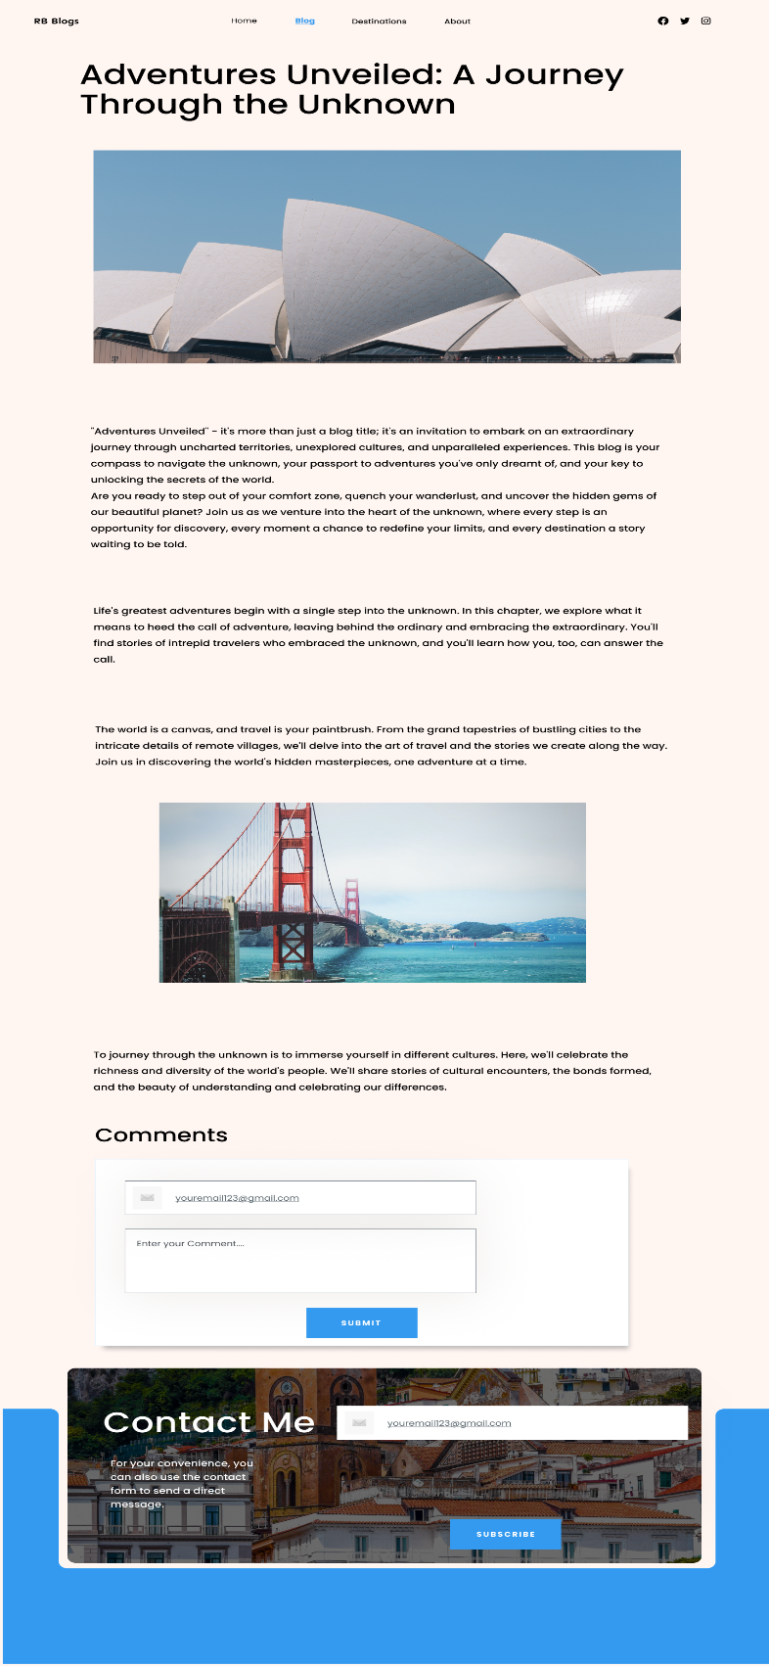

**Page 2 : Blog listing page**

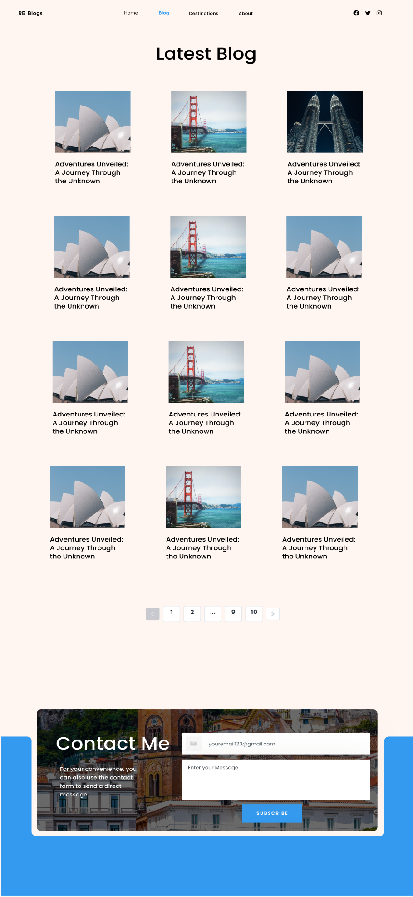

**Page 2 : Destination listing page** 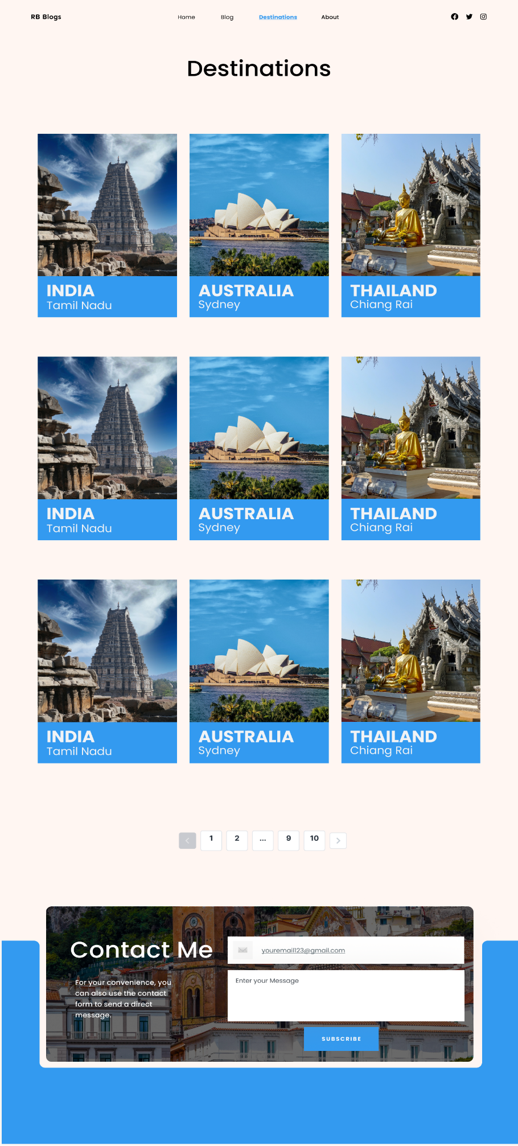

**Page 4: Home Page**

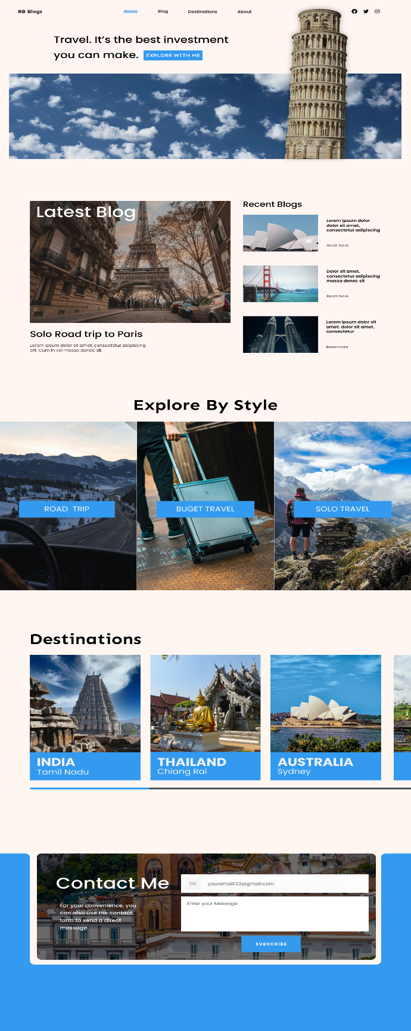

**Figma Design Link:** <https://www.figma.com/file/xCodimi178mci3vWWVjpPc/Personal-Blog-Web-page-design?type=design&node-id=0%3A1&mode=design&t=i4X97jdUgcQ098kp-1>

**Step 2: Wireframing and Information Architecture**

**Content Mapping:**

Created a site map to organize the website's structure and define the main navigation sections (Home, Destinations, Blog, About Us, Contact).

**Wireframes**:

Developed wireframes for key pages, including the home page, blog post page, and category pages, outlining the basic layout and content hierarchy.

**Step 3: Visual Design**

**Style Guide**:

Created a style guide specifying the color scheme, typography, and visual elements. Main colors include earthy tones, with vibrant accents to reflect the spirit of travel.

**Home Page Design**:

Designed the home page with a hero section, recent blog post cards, navigation menu, and footer. Ensured visual consistency with the style guide.

**Blog Post Page Design:**

Designed the individual blog post page, featuring a header, content section, related posts, and comments section.

**Step 4: Interactive Design**

**User Interactions:**

Defined interactions, including click events for buttons and links, hover effects, and animations for an engaging user experience.

**Responsive Design:**

Ensured the design is responsive by adapting layouts for different screen sizes. Documented breakpoints and layout adjustments.

**Step 5: UI Component Library**

**UI Components:**

Created a UI component library with reusable components like buttons, cards, headers, and navigation menus.

**Step 6: Documentation and Annotations**

**Annotations**:

Annotated design elements, explaining their functionality, purpose, and specifications.

**Comments**:

Used Figma's comment feature to facilitate team communication and gather feedback.

**Export Assets**:

Exported design assets in multiple formats (PNG, SVG, etc.) for development.

**Step 7: Team Collaboration**

**Feedback and Revisions**:

Collaborated with team members, collected feedback, and made necessary revisions.

**Conclusion**:

This comprehensive design documentation serves as a detailed reference for the travel blog's design. It provides a clear understanding of design elements, interactions, and the process of creating the design. The design is ready for the development phase, ensuring the vision is accurately implemented.